**PROBLEM STATEMENT**

**KPI'S REQUIREMENT**

We need to analyze key indicators for our pizza sales data to gain insights into our business performance. Specifically, we want to calculate the following metrics:

**1. Total Revenue:** The sum of the total price of all pizza orders.

**2. Average Order Value:** The average amount spent per order, calculated by dividing the total revenue by the total number of orders.

**3. Total Pizzas Sold:** The sum of the quantities of all pizzas sold.

**4. Total Orders:** The total number of orders placed.

**5. Average Pizzas Per Order:** The average number of pizzas sold per order, calculated by dividing the total number of pizzas sold by the total number of orders.

**CHARTS REQUIREMENT**

We would like to visualize various aspects of our pizza sales data to gain insights and understand key trends. We have identified the following requirements for creating charts:

**1.Daily Trend for Total Orders:**

Create a bar chart that displays the daily trend of total orders over a specific time period. This chart will help us identify any patterns or fluctuations in order volumes on a daily basis.

**2.Hourly Trend for Total Orders:**

Create a line chart that illustrates the hourly trend of total orders throughout the day. This chart will allow us to identify peak hours or periods of high order activity.

**3.Percentage of Sales by Pizza Category:**

Create a pie chart that shows the distribution of sales across different pizza categories. This chart will provide insights into the popularity of various pizza categories and their contribution to overall sales.

**4.Percentage of Sales by Pizza Size:**

Generate a pie chart that represents the percentage of sales attributed to different pizza sizes. This chart will help us understand customer preferences for pizza sizes and their impact on sales.

**5.Total Pizzas Sold by Pizza Category:**

Create a funnel chart that presents the total number of pizzas sold for each pizza category. This chart will allow us to compare the sales performance of different pizza categories.

**6.Top 5 Best Sellers by Total Pizzas Sold:**

Create a bar chart highlighting the top 5 best-selling pizzas based on the total number of pizzas sold. This chart will help us identify the most popular pizza options.

**7.Bottom 5 Worst Sellers by Total Pizzas Sold:**

Create a bar chart showcasing the bottom 5 worst-selling pizzas based on the total number of pizzas sold. This chart will enable us to identify underperforming or less popular pizza options.

SQL QUERIES

SELECT * FROM PIZZA_SALES

1.TOTAL REVENUE

SELECT SUM(TOTAL_PRICE) AS TOTAL_REVENUE FROM PIZZA_SALES



2.AVERAGE ORDER VALUE

SELECT SUM(TOTAL_PRICE)/COUNT(DISTINCT ORDER_ID) AS AVERAGE_ORDER_VALUE FROM PIZZA_SALES

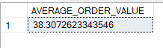

3.TOTAL PIZZAS SOLD

SELECT SUM(QUANTITY) AS TOTAL_PIZZAS_SOLD FROM PIZZA_SALES



4. TOTAL ORDERS

SELECT COUNT(DISTINCT ORDER_ID) AS TOTAL_ORDERS FROM PIZZA_SALES

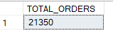

5.AVERAGE PIZZAS PER ORDER

SELECT CAST(CAST(SUM(QUANTITY) AS DECIMAL(10,2))/

CAST(COUNT(DISTINCT ORDER_ID) AS DECIMAL(10,2)) AS DECIMAL(10,2)) AVG_PIZZAS_PER_ORDER

FROM PIZZA_SALES

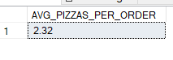

6.DAILY TREND FOR TOTAL ORDERS

SELECT DATENAME(DW,ORDER_DATE) AS ORDER_DAY,

COUNT(DISTINCT ORDER_ID) AS TOTAL_ORDERS FROM PIZZA_SALES

GROUP BY DATENAME(DW,ORDER_DATE)

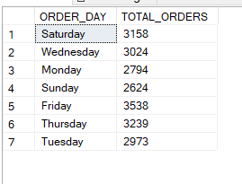

7.HOURLY TREND FOR TOTAL ORDERS

SELECT DATEPART(HOUR,ORDER_TIME) AS ORDER_HOURS,

COUNT(DISTINCT ORDER_ID) AS TOTAL_ORDERS FROM PIZZA_SALES

GROUP BY DATEPART(HOUR,ORDER_TIME)

ORDER BY DATEPART(HOUR,ORDER_TIME)

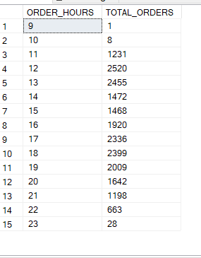

8.PERCENTAGE OF SALES PIZZA CATEGORY

SELECT PIZZA_CATEGORY,SUM(TOTAL_PRICE)*100/

(SELECT SUM(TOTAL_PRICE) FROM PIZZA_SALES) AS PCT

FROM PIZZA_SALES

GROUP BY PIZZA_CATEGORY

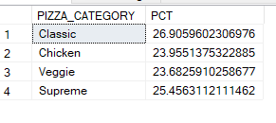

9. PERCENTAGE OF SALES BY PIZZA_SIZE

SELECT pizza_size, CAST(SUM(total_price) AS DECIMAL(10,2)) as total_revenue,

CAST(SUM(total_price) * 100 / (SELECT SUM(total_price) from pizza_sales) AS DECIMAL(10,2)) AS PCT

FROM pizza_sales

GROUP BY pizza_size

ORDER BY pizza_size

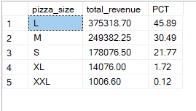

10. TOP 5 BEST SELLERS BY PIZZAS SOLD

SELECT Top 5 PIZZA_NAME, SUM(quantity) AS Total_Pizza_Sold

FROM PIZZA_SALES

GROUP BY PIZZA_NAME

ORDER BY Total_Pizza_Sold DESC

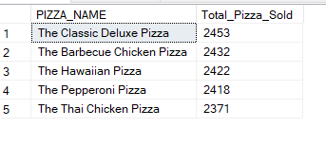

11. BOTTOM 5 BEST SELLERS BY PIZZAS SOLD

SELECT Top 5 PIZZA_NAME, SUM(quantity) AS Total_Pizza_Sold

FROM PIZZA_SALES

GROUP BY PIZZA_NAME

ORDER BY Total_Pizza_Sold ASC

